PROGRAMS USING RAPTOR:

1.Program to convet Hexa to decimal

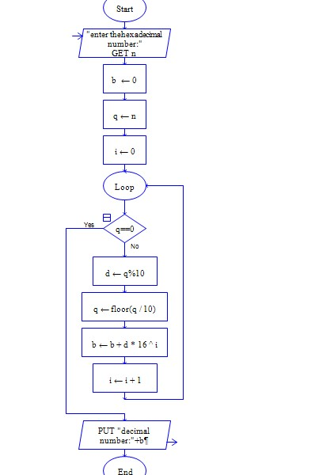

Program to convert octal to decimal

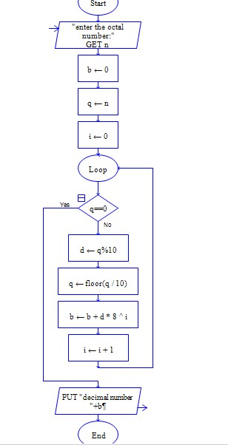

C Program to read a number and find its square

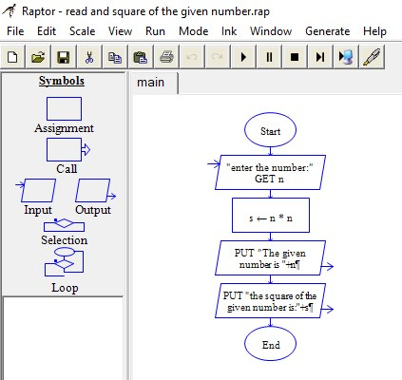

C Program to find the biggest of three numbers

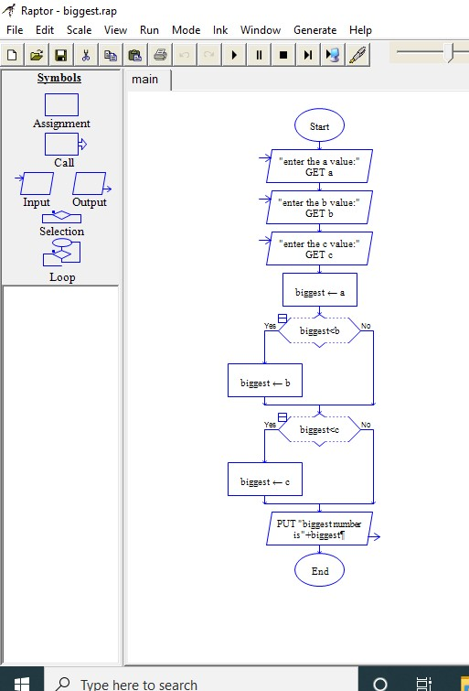

1. C Program to find leap year

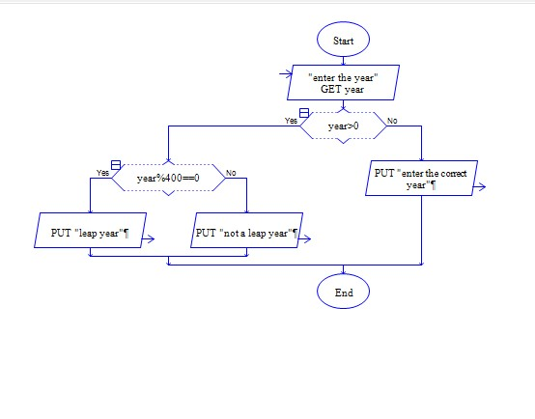

1. C Program to prepare mark list using elif statement

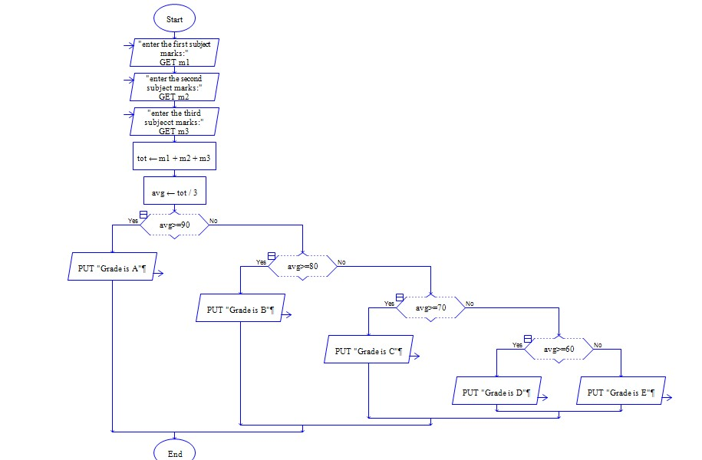

1. C Program to perform arithmetic operation on two numbers

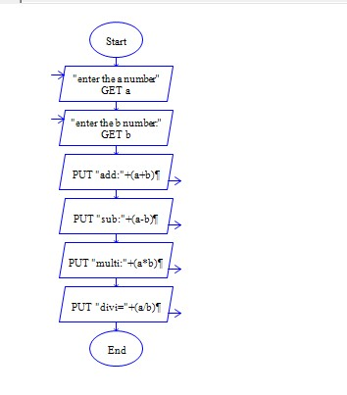

8.C Program to print n natural number

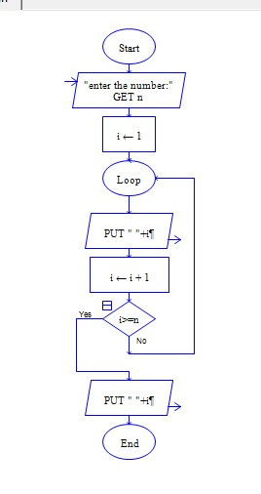

9. C Program to find area of different shapes?

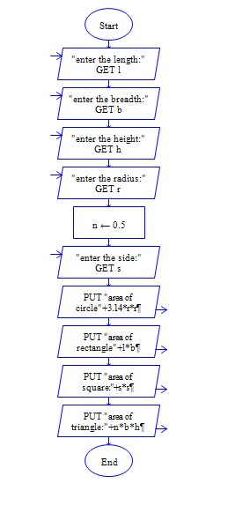

10.C Program to check number is palindrome

